**Module 1: Effective Communication**

**1)Thank you Email**

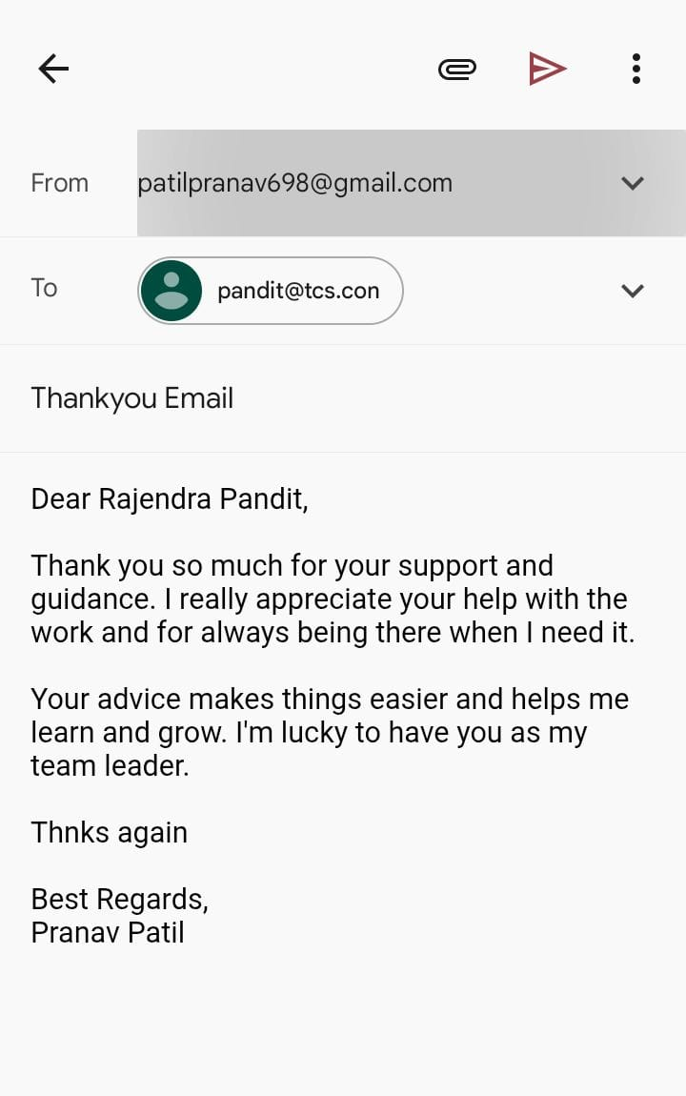

**2) Letter of Apology**

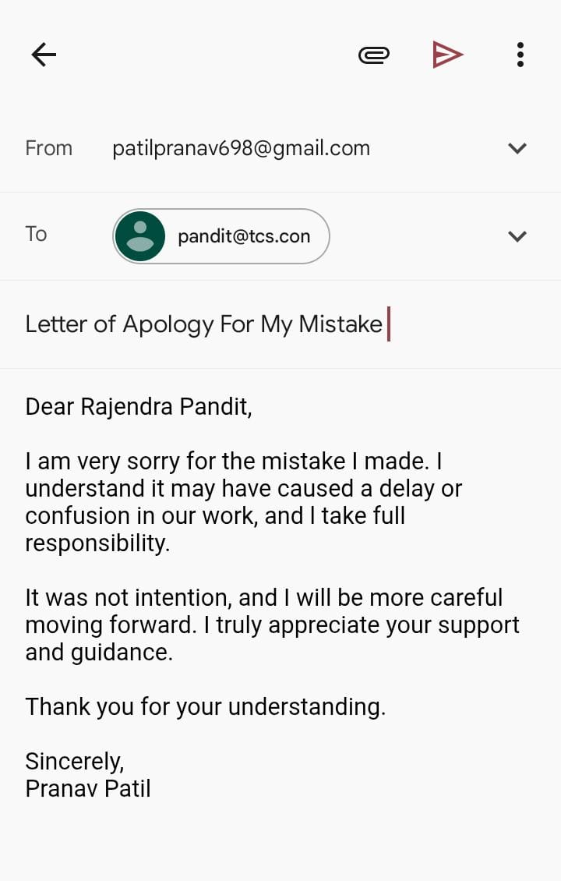

**3) Email of Inquiry for Requesting Information**

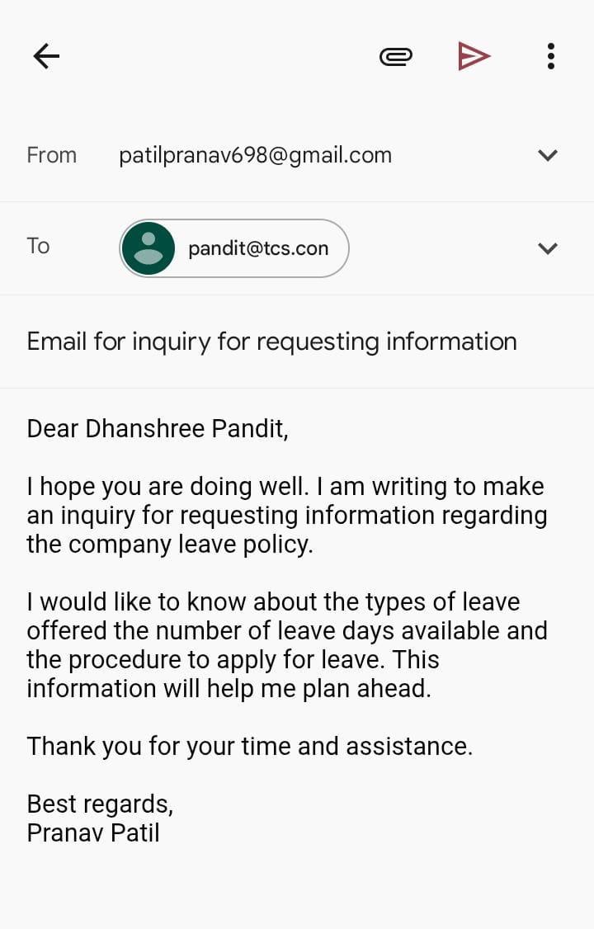

**4) Asking for a Raise in Salary**

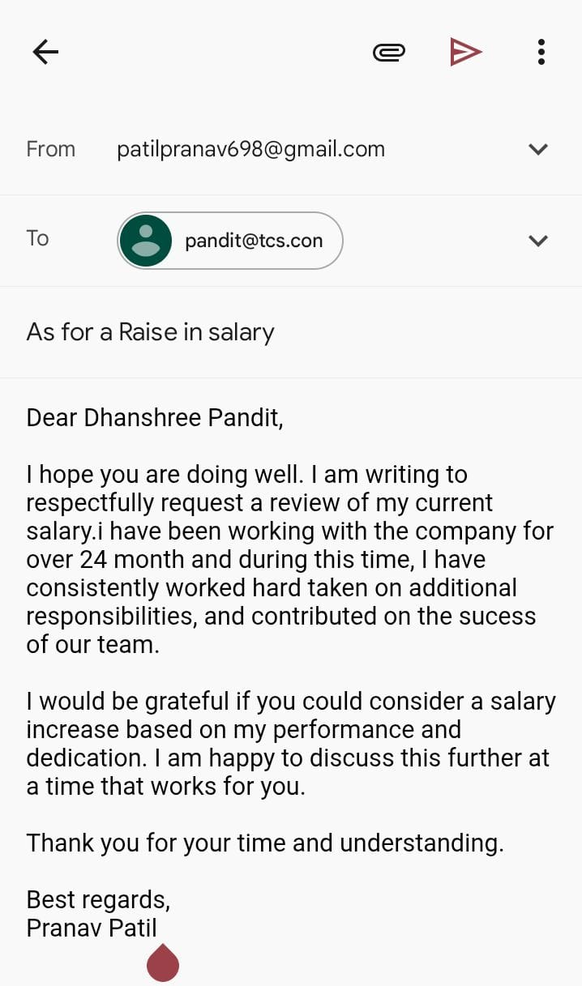

**5) Resignation Email**

